FIELD REPORT
Introduction
- Place: Icheme (Okwir) HC III
- Location: Icheme, Oyam district
- Date of visit: 24th August 2026

- General observations
- The verification exercise was conducted with the support of the facility in charge, who was available and actively participated throughout the process and provided the relevant documentation, including the delivery note, to support the verification exercise.
- All assets provided to the facility under UgIFT were physically verified and accounted for during the exercise. The in charge actively participated in the verification process by providing information and guiding the verification team on the location and use of the assets.
Special notes
- The UgIFT-provided equipment and assets were not engraved or otherwise marked for identification. This made it difficult to distinguish UgIFT-provided equipment from other equipment belonging to the facility.
- The facility does not have a reliable electricity supply. This limits the use of equipment that requires power to operate, including equipment such as the oxygen concentrator. The lack of power therefore affects the facility's ability to fully utilize some of the equipment provided under UgIFT. Where grid electricity is not immediately feasible, appropriate alternative power solutions should be considered.
- Some of the furniture provided was made of wood and was reported to have deteriorated quickly with use. Examples include chairs and tables, which had sustained damage.

The table below illustrates some physical status of the verified assets with photographic evidence.
Table XXX: Physical verification photos
ICHEME-OKWIR HC III SIGN POST | 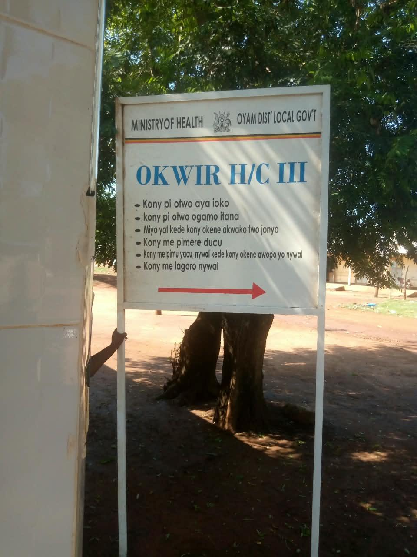
TYPICAL SET OF STAFF QUARTER’S BLOCK  (HOUSE BLOCK WITH TWO UNITS, KITCHEN AND TWO STANCE TOILET BLOCK) | 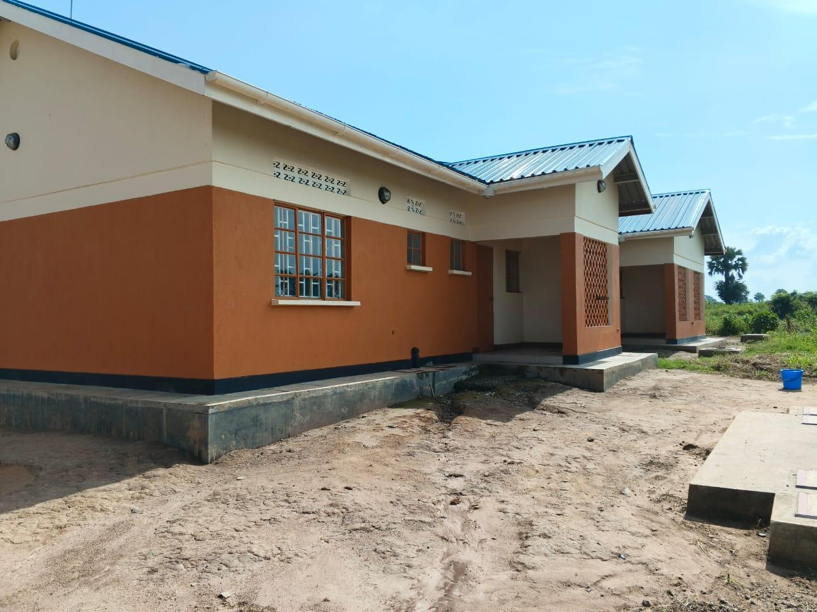
TYPICAL SET OF STAFF QUARTER’S BLOCK  (BACK VIEW HOUSE BLOCK WITH TWO UNITS, KITCHEN AND TWO STANCE TOILET BLOCK) | 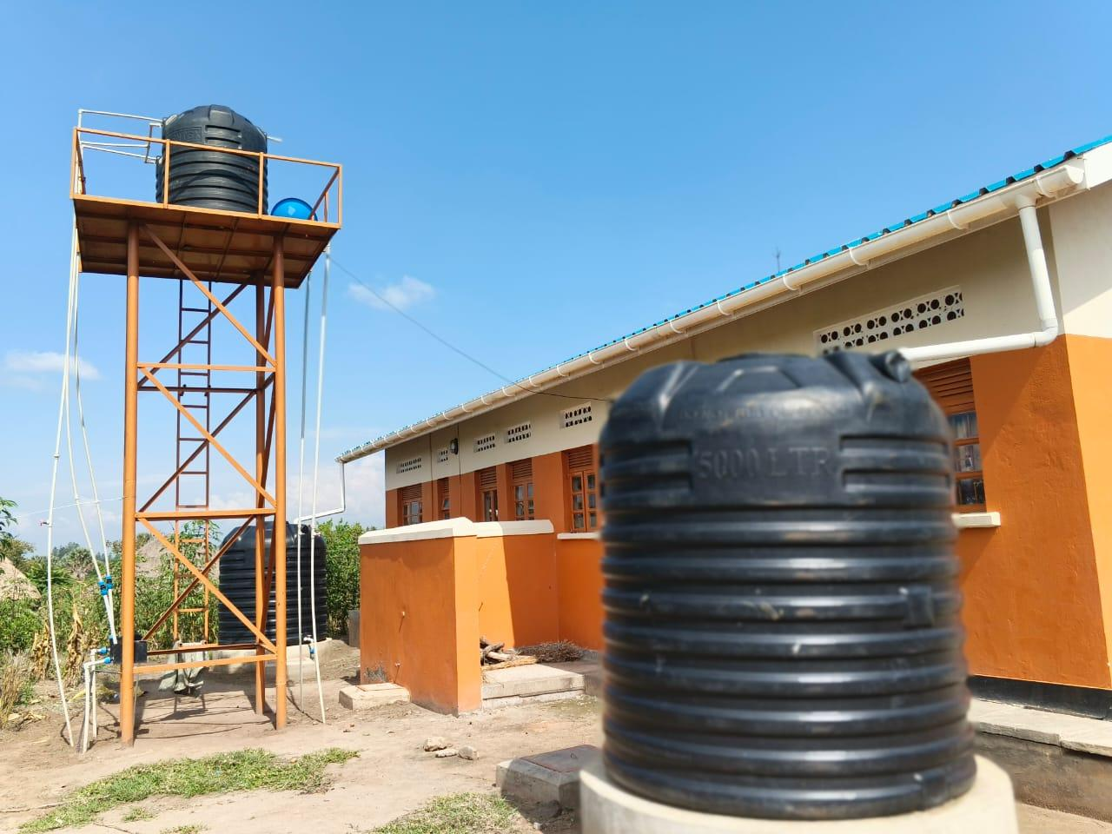
TYPICAL SET OF STAFF QUARTER’S BLOCK  (HOUSE BLOCK WITH THREE UNITS, KITCHEN AND TWO STANCE TOILET BLOCK) | 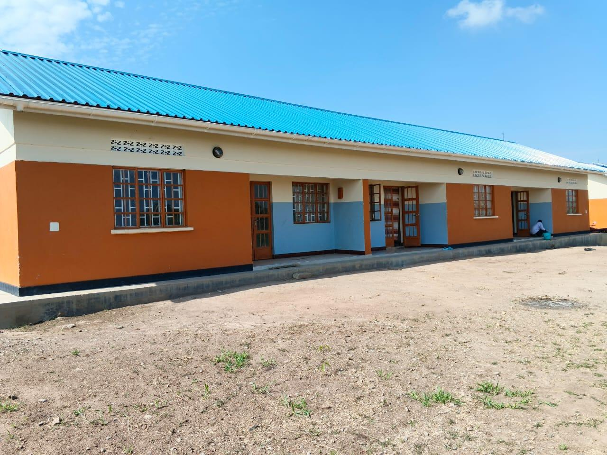
STAFF PIT LATRINES | 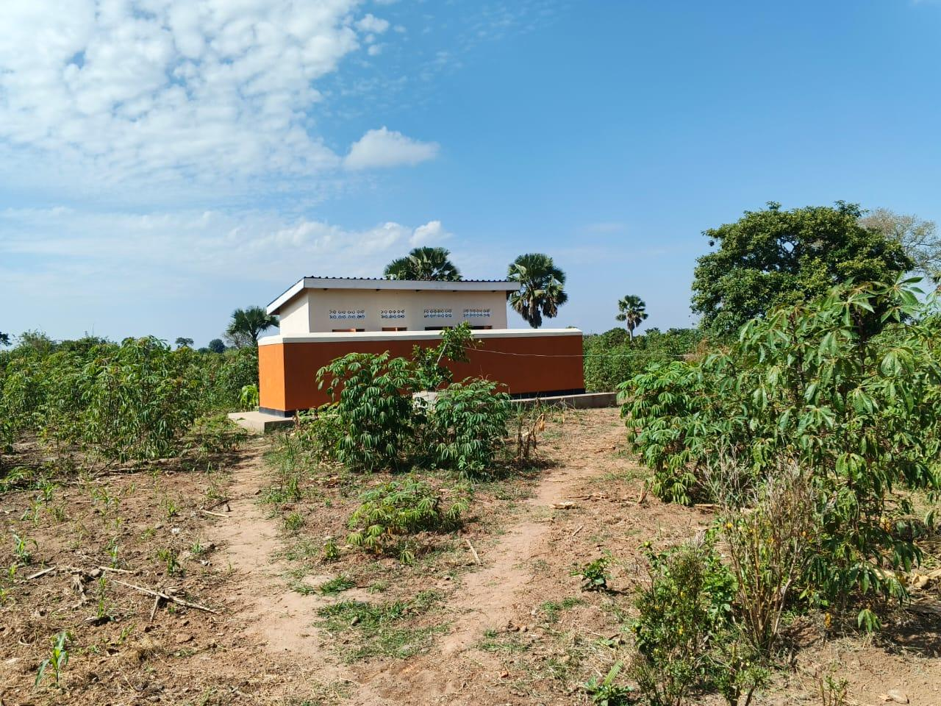
MATERNITY WARD (FRONT VIEW) | 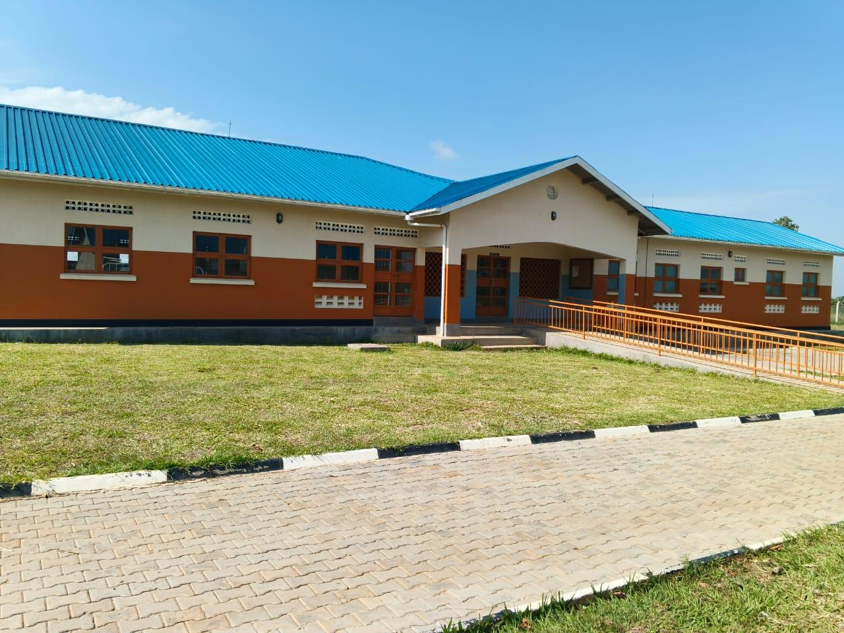
MATERNITY WARD (BACK VIEW) WITH THE TANKS SUPPLYING WATER TO THE WARD | 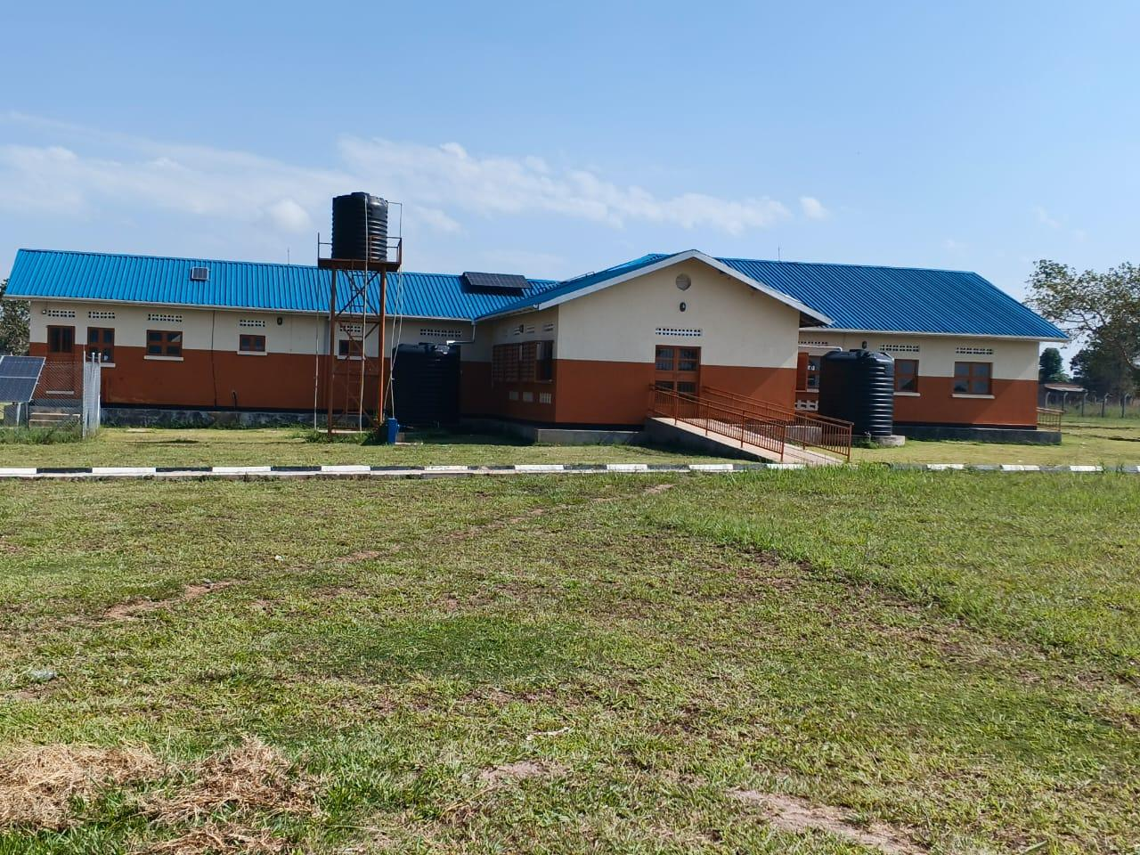
PATIENT PIT LATRINES (4 STANCE FOR BOTH MALE AND FEMALE) | 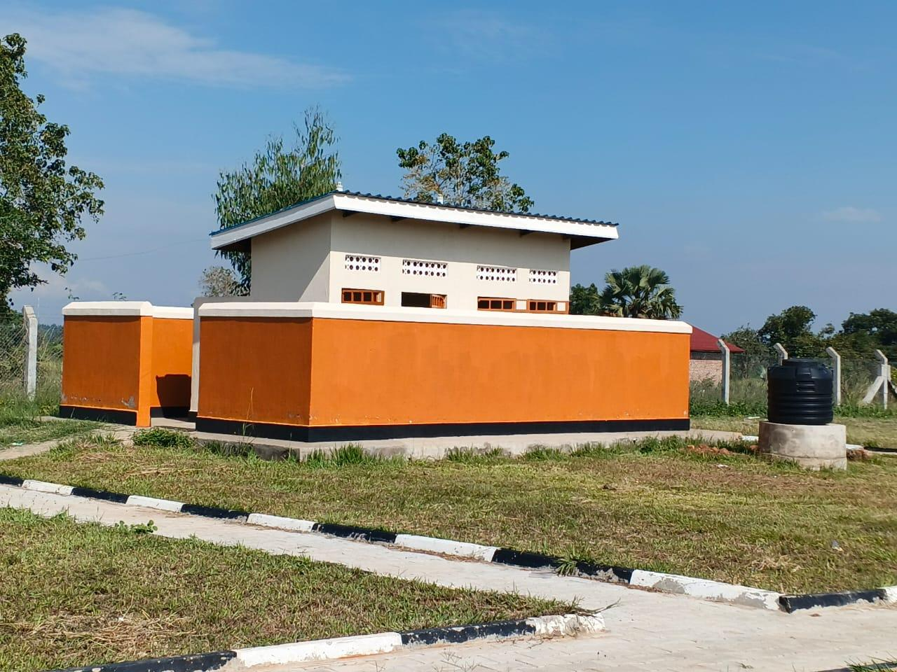
PLACENTA PIT | 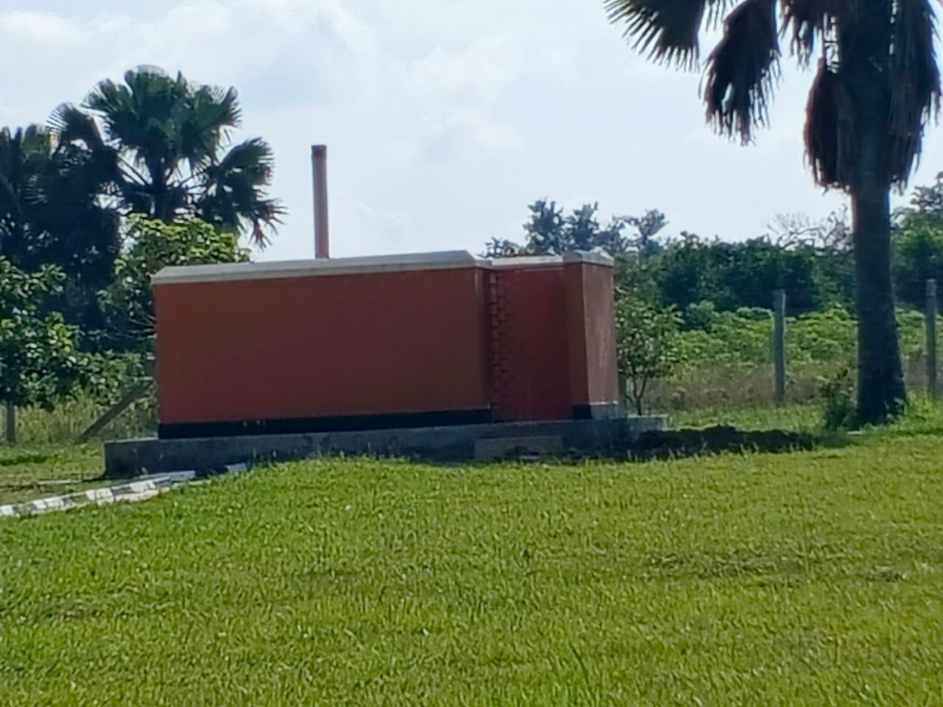
OPD BLOCK (FRONT VIEW) | 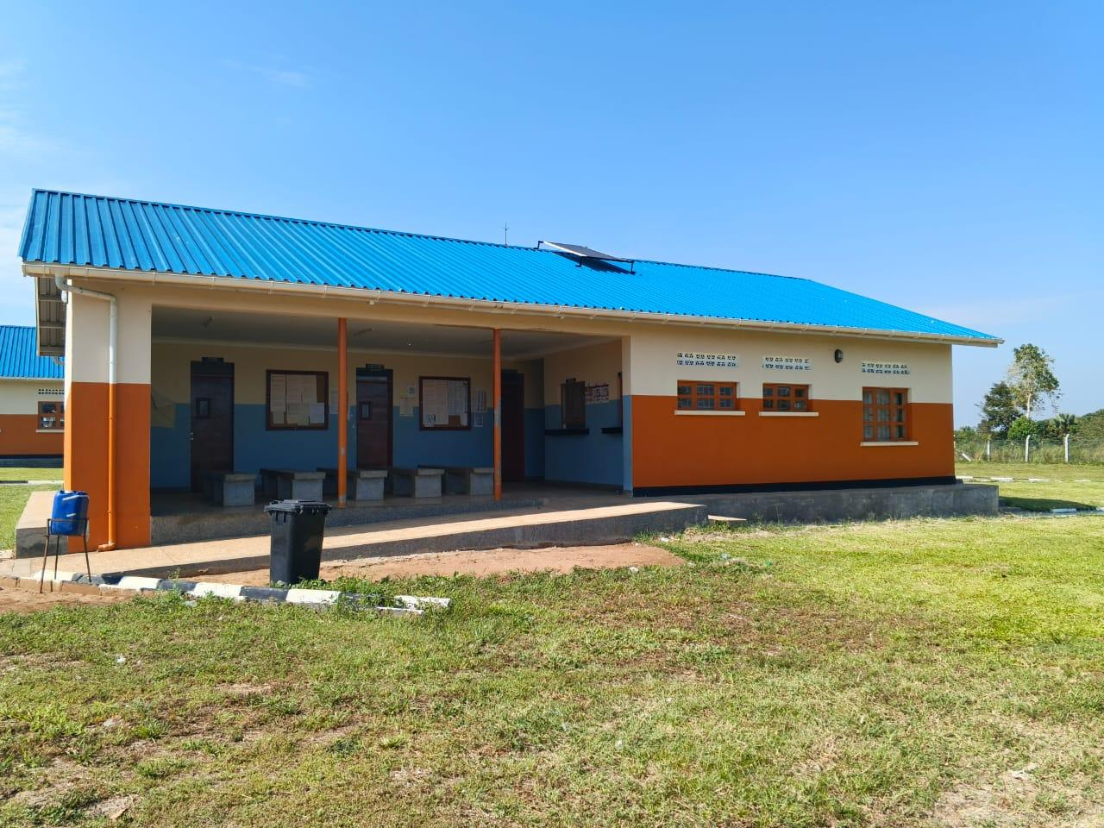
OPD BLOCK (BACK VIEW) | 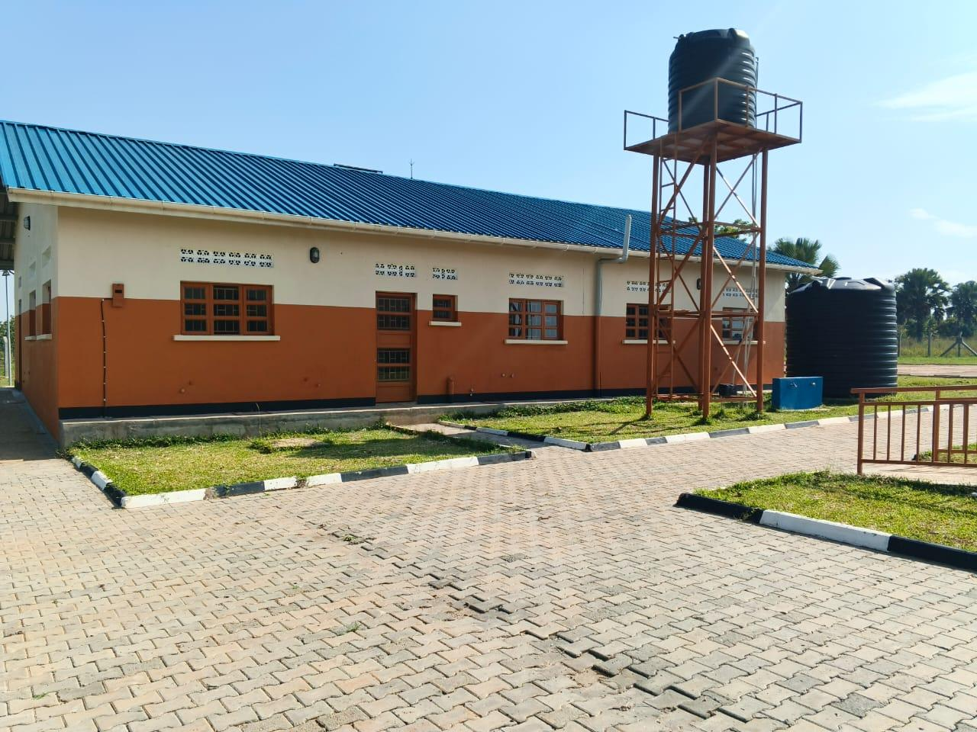
BENCH | 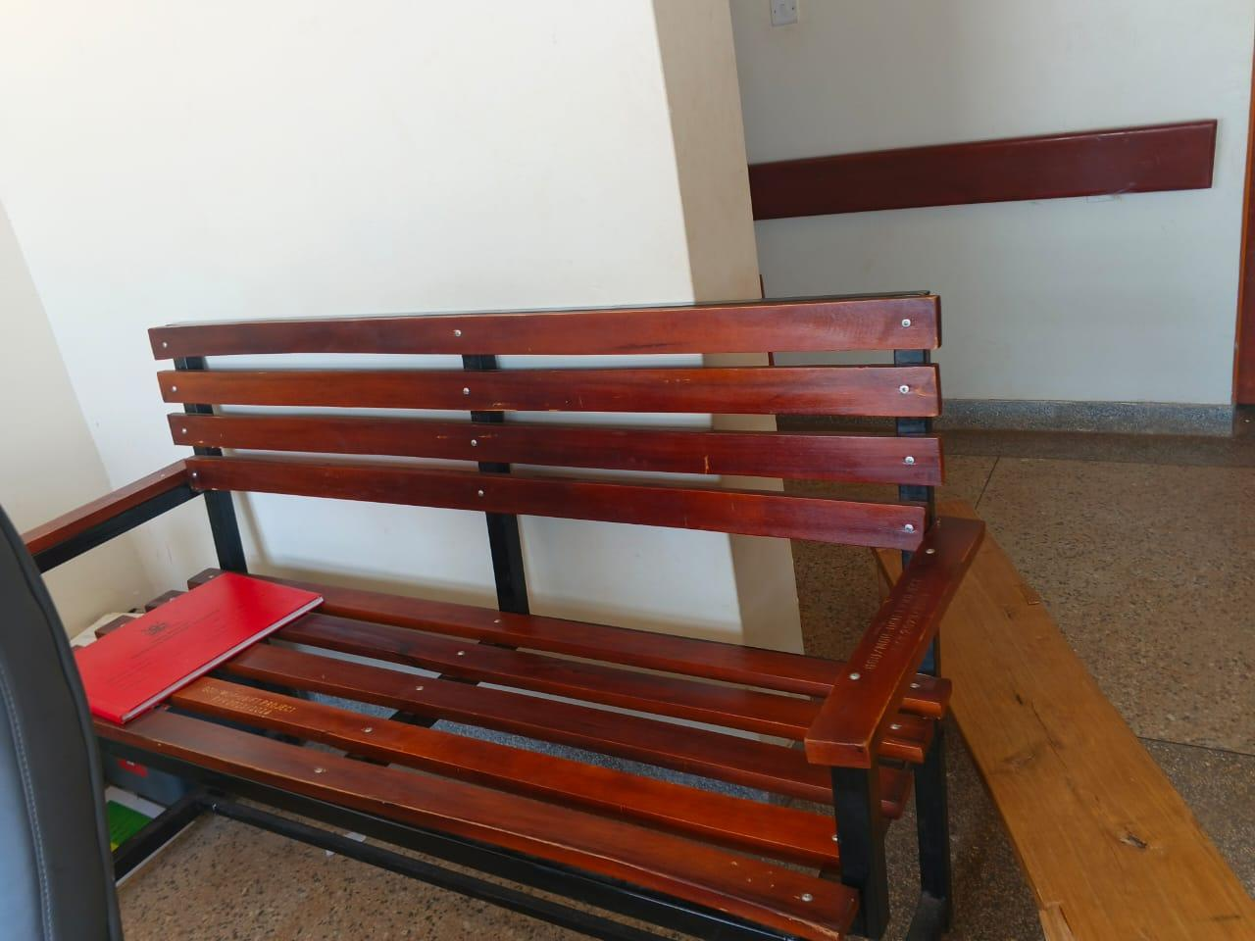
SAMPLE OF ENGRAVED BENCH | 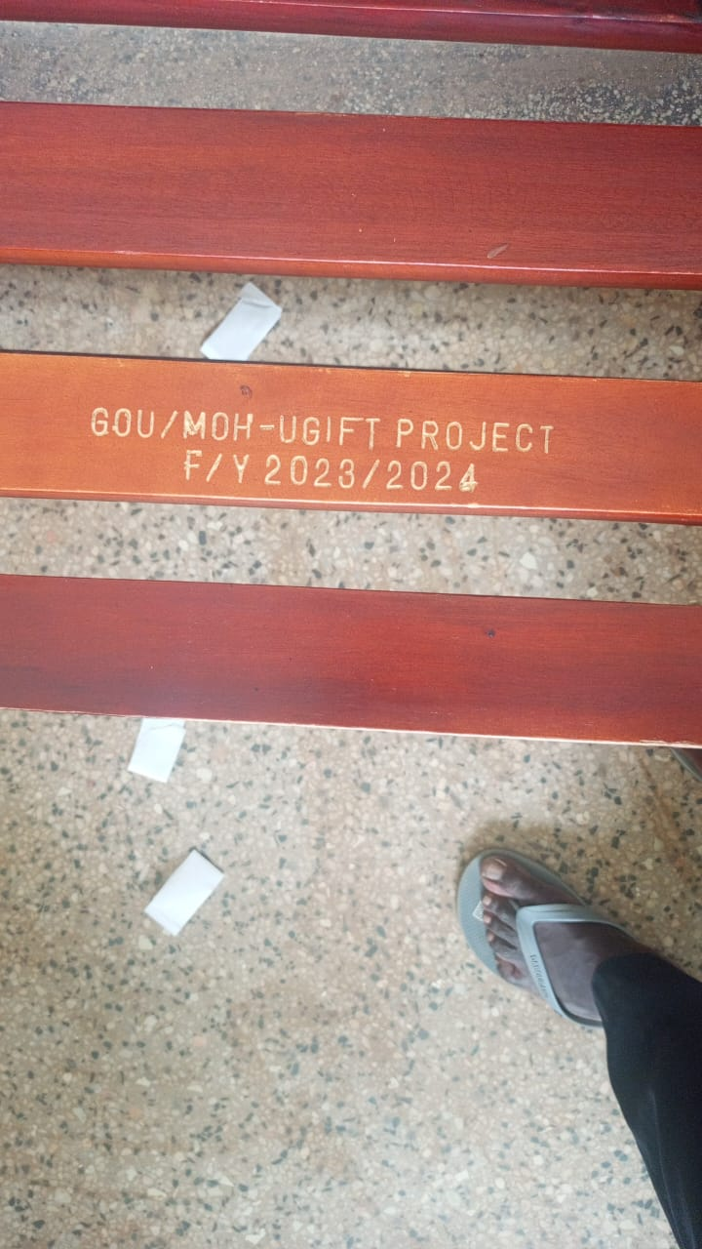
DESK | 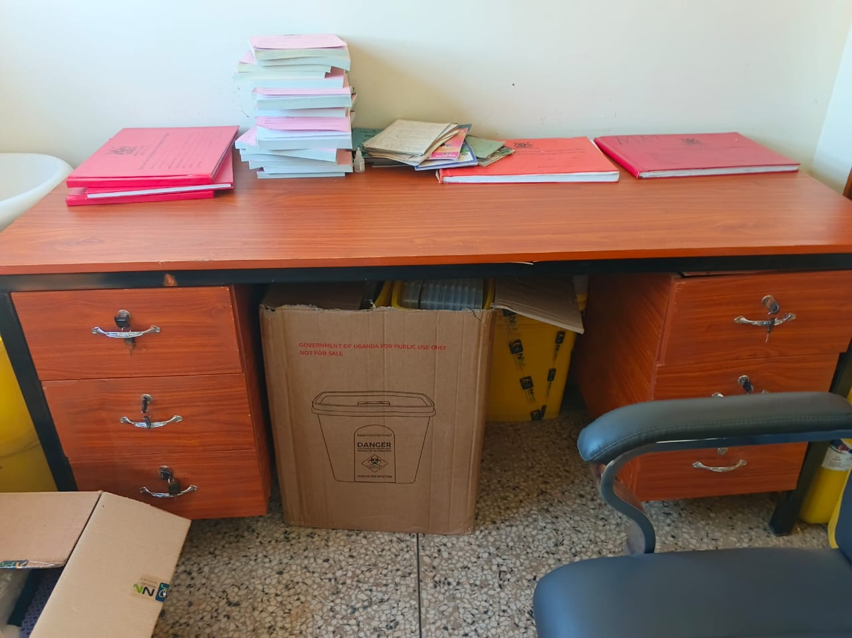
SAMPLE OF ENGRAVED DESK | 